EADS NA Defense Test & Services

Software Design Document

Function Generator Functionality
WCEM Driver - WcemFncGen.dll

SDD-WcemFncGen
Version 0.00
06/14/05

This document and the information contained herein are proprietary to EADS NA Defense and may not be disclosed in whole or in part to any parties without the expressed written consent of EADS NA Defense.

PAWS is a registered trademark of the TYX Corporation.

© EADS NA Defense Test & Services
1222 Lucas Ave. Suite 200
St. Louis MO 63103
phone (314) 727 1337
fax (314) 727 6750
Software Design Document

Version 0.00

History of changes
0: Initial Release

Change Table

Change | Date | Paragraph

1 Scope 5
1.1 Identification 5
1.2 System Overview 5
1.3 Document Overview 5
2 Reference Documents 5
3 System-Wide Design Overview 5
3.1 Assumptions and Dependencies 5
3.2 General Constraints 6
3.3 Goals and Guidelines 6
3.4 Safety and Security Considerations 6
3.5 Development Methods 6
4 System Architectural Design 6
4.1 System Components 7
4.2 Interface design 8
5 Detailed Design 9
5.1 Classification 9
5.2 ATLAS Modifier Definition 9
5.3 Port Names 12
5.4 Processing 12
5.5 Function Generator Programming Specifications 12
5.5.1 Programming Resolution 12
5.5.2 Programming Accuracy 12
5.6 Processing 12
6 Requirements traceability 12
7 Notes 13
7.1 ATLAS Examples 13
7.1.1 Setup of 50MHz Clock 13
7.1.2 AC Signal 13
8 Appendix A – Mathematical Equations 13

Scope

Identification
The software configuration component WcemFncGen.dll provides the software routines necessary to control the Function Generator.

System Overview
The PAWS system provides several methods of interfacing the compiled ATLAS object code with the test system instruments. The method used by this module is the Windows CIIL Emulation Module (WCEM). This mode of instrument control, the PAWS WRTS calls the WcemFncGen.dll via ATLAS single action verb related functions. The WcemFncGen.dll queries the WRTS for modifier values and other parameters and sends the necessary commands to the instrument.

Document Overview
The document defines the detailed software design for the PAWS WCEM driver for the FncGen. This document specifies the value ranges of all the ATLAS modifiers and modifier value ranges and how they are used to control the Function Generator.

Reference Documents
- Software Requirements Specification for Third Echelon Test Set DEFCOT&S-3536-SRS-001
- PERFORMANCE SPECIFICATION FOR THE THIRD ECHELON TEST SET (TETS) MARCORSYSCOM-PD-02-001 12/1/2003
- Computer Programming Manual (CPM) for the Third Echelon Test System (TETS) REV. E P/N 93006A0026
- IEEE std. 716-1989 C/ATLAS Test Language
- General Notes for ATLAS Implementation Doc # 7992052 Rev.01 Aug 10 2005

System-Wide Design Overview
The PAWS development system provides the ability to code a test program in an extended / subset of the IEEE std. 716-1989 C/ATLAS Test Language. The PAWS development system provides the ability to modify the ATLAS subset with special nouns and modifiers (primarily analog) to meet special requirements.

Assumptions and Dependencies
The following assumptions and dependencies are made:

- The TETS ATLAS subset will contain the common ATLAS extensions found in most extended subsets of ATLAS (e.g. TRIG-SOURCE, TRIG-SLOPE, etc.)
- The TETS ATLAS subset will contain all required legacy ATLAS extensions that are not replaceable with the standard or common ATLAS extensions.
- The full instrument range will be implemented when they exceed the ranges in the system requirements specification.
- The full functionality of the instrument will be implemented to the extent possible where the ATLAS mapping can be defined. (Detailed below).

General Constraints
The sections below will detail which of the ATLAS modifiers are used and how they are used to control the FncGen.

Goals and Guidelines
- To the extent possible, map the ATLAS modifiers to instrument controls in a common sense manner.
- Implement the full range and functionality as can be supported by the extended subset of ATLAS.

Safety and Security Considerations
No safety or security considerations for this instrument.

Development Methods
As described in the “ARC PAWS WCEM Software Development Style Guide”.

System Architectural Design
The PAWS WCEM driver is invoked on TPS load, TPS Unload, WRTS “Reset” / ATLAS “REMOVE, ALL”, and the derived “Single Action” ATLAS actions. The following diagram shows the major functions called from the WRTS through tables created by the WCEM Wizard in Wrapper.cpp. (See the “ARC PAWS WCEM Software Development Style Guide” for details). The essence of the WCEM driver is defined as a class CFncGen. When multiple instruments (FncGens) are available in the station, an instance of the CFncGen class will be instantiated. Therefore, the member variables and methods need only control a single instrument.
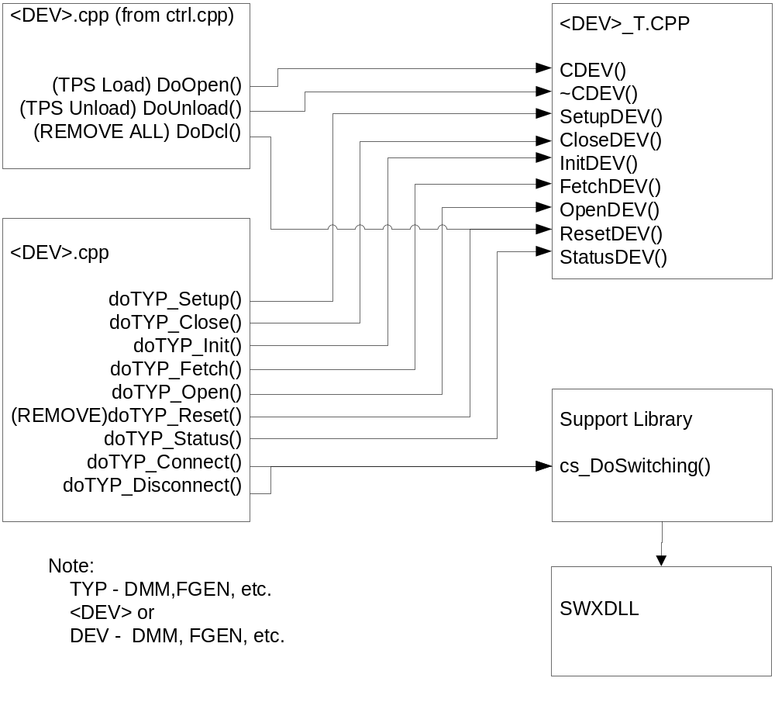
Figure 4.0 WCEM Function Relationships

System Components
The WCEM driver will consist of:

- A Microsoft Visual C++ project to build the WCEM
  - WCEM Wizard generated interface files
    - Wrapper.cpp
    - error.cpp
    - key.h
  - Configuration Information
    - FncGen.rc
    - resource.h
  - Updated Template File
    - FncGen.cpp
  - The programmer generated driver file FncGen_T.cpp

- A PAWS Developer’s Studio project file for the benchmark FncGen.PAW
  - An ATLAS program or programs to test the driver (Benchmark)
  - A Device Database static Description

Interface design

Function | Purpose
CFncGen(bool sim, int dbglvl, int addr) | This function is used to initialize the instrument, obtain a handle from VISA or other controller software, and establish if the device is in simulation mode and / or debug.
~CFncGen(void) | This function shuts down the instrument and releases the device handle.
SetupFncGen(int fnc) | This function is the entry point for the setup action. The argument is the FNC number from the DeviceDB Static Description.
StatusFncGen(void) | This function queries the instrument for status and reports any errors to the RTS via the error handling mechanisms
FetchFncGen(int fnc) | This function is responsible for retrieving measured values from the instrument and returns them to the RTS via the fetch API in WCEM or other support libraries
InitiateFncGen(int fnc) | This function controls the ATLAS INITIATE actions and is responsible for enabling or triggering a signal
ResetFncGen(int fnc) | This function is responsible for resetting the instrument. The argument 0 will be reserved for a RESETALL action and shall reset the instrument regardless of the current state of the device. Arguments > 0 may use a state variable to determine if the device is currently reset.
CloseFncGen(int fnc) | This function is responsible for the ATLAS CLOSE verb and shall close any internal relays within the instrument and will enable the output or input to the device.
OpenFncGen(int fnc) | This function is responsible for the ATLAS OPEN verb and will disable the output or input of the instrument.

Detailed Design

Classification
This module is unclassified.

ATLAS Modifier Definition
The following table specifies the Nouns / Measured Characteristics / Modifiers used to control the FncGen:

Modifier | Dims | Value Range | Default | XML | Misc
AC SIGNAL
VOLTAGE | Vrms | 3.54 mV to 5.66 V |  |  | Vp/1.414
VOLTAGE-P | Vp | 5 mV to 8 V |  |  | Vpp/2
VOLTAGE-PP | Vpp | 10 mV to 16 V
DC-OFFSET | V | -7.19 V to 7.19 V
FREQ | Hz | 100.0 μHz to 50 MHz
BURST | Cycles | 4 cycles to 100 cycles |  |  | Burst Length
PERIOD | Sec | 20 nSec to 10 kSec
BANDWIDTH | Hz | 20 MHz, 25 MHz, 50 MHz
SQUARE WAVE
VOLTAGE-P | Vp | 5 mV to 8 V |  |  | Vpp/2
VOLTAGE-PP | Vpp | 10 mV to 16 V
DC-OFFSET | V | -7.19 V to 7.19 V
DUTY-CYCLE | Pc | 1 Pc to 99 Pc
FREQ | Hz | 100 μHz to 50 MHz
BURST | Cycles | 4 cycles to 100 cycles |  |  | Burst Length
BURST-REP-RATE | Hz | .001001 Hz to 16667 Hz
PERIOD | Sec | 20 nSec to 10 kSec
BANDWIDTH | Hz | 20 MHz, 25 MHz, 50 MHz
TRIANGULAR WAVE SIGNAL
VOLTAGE-P | Vp | 5 mV to 8 V |  |  | Vpp/2
VOLTAGE-PP | Vpp | 10 mV to 16 V
DC-OFFSET | V | -7.19 V to 7.19 V
FREQ | Hz | 100 μHz to 1.0 MHz
BURST | Cycles | 4 cycles to 100 cycles |  |  | Burst Length
BURST-REP-RATE | Hz | .001001 Hz to 16667 Hz
PERIOD | Sec | 100 μSec to 10 kSec
BANDWIDTH | Hz | 20 MHz, 25 MHz, 50 MHz
RAMP SIGNAL
VOLTAGE-P | Vp | 5 mV to 8 V |  |  | Vpp/2
VOLTAGE-PP | Vpp | 10 mV to 16 V
DC-OFFSET | V | -7.19 V to 7.19 V
FREQ | Hz | 100.0 μHz to 1 MHz
RISE-TIME | Sec | 10 nSec to 4950 Sec
FALL-TIME | Sec | 10 nSec to 4950 Sec
RAMP-NEG-SLOPE | V/SEC | 2.02 uV/Sec to 1.6 GV/Sec |  |  | Documentation purposes only
RAMP-POS-SLOPE | V/SEC | 2.02 uV/Sec to 1.6 GV/Sec |  |  | Documentation purposes only
BURST | Cycles | 4 cycles to 100 cycles |  |  | Burst Length
BURST-REP-RATE | Hz | .001001 Hz to 16667 Hz
PERIOD | Sec | 100 μSec to 10 kSec
BANDWIDTH | Hz | 20 MHz, 25 MHz, 50 MHz
PULSED DC
VOLTAGE-P | Vp | 5 mV to 8 V |  |  | Vpp/2
PRF | Hz | 100.0 μHz to 1 MHz
VOLTAGE-PP | Vpp | 10 mV to 16 V
DC-OFFSET | V | -7.19 V to 7.19 V
RISE-TIME | Sec | 1 μSec to 9900 Sec
FALL-TIME | Sec | 1 μSec to 9900 Sec
PERIOD | Sec | 100 μSec to 10 kSec
BANDWIDTH | Hz | 20 MHz, 25 MHz, 50 MHz
PULSE-WIDTH | Sec | 1 μSec to 9900 Sec
DC SIGNAL
VOLTAGE | V | -8 V to 8 V
SINC WAVE
VOLTAGE-P | Vp | 5 mV to 8 V |  |  | Vpp/2
VOLTAGE-PP | Vpp | 10 mV to 16 V
BURST | Cycles | 4 cycles to 100 cycles |  |  | Burst Length
FREQ | Hz | 100 μHz to 1.0 MHz |  |  | pulse-repetition frequency in the burst
PERIOD | Sec | 100 μSec to 10 kSec |  |  | pulse-repetition period in the burst
BANDWIDTH | Hz | 20 MHz, 25 MHz, 50 MHz
EXPONENTIAL PULSE WAVE
VOLTAGE-P | Vp | 5 mV to 8 V |  |  | Vpp/2
VOLTAGE-PP | Vpp | 10 mV to 16 V
BURST | Cycles | 4 to 100 Cycles
DC-OFFSET | V | -7.19 V to 7.19 V
FREQ | Hz | 100 μHz to 1.0 MHz
PRF | Hz | 100 μHz to 1.0 MHz |  |  | Repetition rate in the burst
EXPONENT |  | -200 to 200
PERIOD | Sec | 100 μSec to 10 kSec
BANDWIDTH | Hz | 20 MHz, 25 MHz, 50 MHz
WAVEFORM
VOLTAGE | V | 3.54 mV to 5.66 V |  |  | Vp/1.414
DC-OFFSET | V | -7.19 V to 7.19 V
STIM |  | 10 to 64536 |  |  | 16 bit Data Words
SAMPLE-SPACING | Sec | 10 nSec to 10 Sec
COMMON MODIFIERS
EVENT-GATE-FROM
EVENT-GATE-TO
STROBE-TO-EVENT |  |  |  |  | Triggers/Syncs
EVENT-SLOPE |  | POS, NEG |  |  | Trig In Only
EVENT-OUT |  |  |  |  | Triggers/Syncs
EVENT-DELAY | Sec | 0.1 Sec to 1000 Sec |  |  | Trig Delay
EVENT-EACH-OCCURRENCE |  |  |  |  | Triggers/Syncs
EVENT-GATED-BY |  |  |  |  | Triggers/Syncs
EVENT-SYNC |  |  |  |  | Triggers/Syncs
TEST-EQUIP-IMP | Ohm | 50 Ohm, 1 MOhm
MAX-TIME | Sec | 0 Sec to 1000 Sec

Port Names
The Port Names in the table below provide the naming convention utilized in the Switch Data Base and Model for interface control and management along with the connection field mnemonics to be used by ATLAS programs.

Notes:
CNX Field | Port Name | Instrument
HI | FGEN_x-HI | Output
VIA | FGEN_x-VIA | Output
SYNC-OUT | FGEN_x-SYNC | Output
EVENT-OUT | FG-EvArm
EVENT-GATE-FROM | FG-EvArm
EVENT-GATE-TO | FG-EvArm
EVENT-SYNC | FG-EvArm
EVENT-GATE-START | FG-EvArm
EVENT-GATE-STOP | FG-EvArm
EVENT-STROBE | Event-Port
EVENT-GATED-BY | FG-EvArm
EVENT-EACH-OCCURRENCE | FG-EvArm
1. Where ‘x’ is the number of devices in the test station.

Processing
There are no special processing requirements other than normal ATLAS interpretation of the keywords.

Function Generator Programming Specifications

Programming Resolution
Voltage: 4 digits
Frequency: 7 digits

Programming Accuracy
Voltage: +/- 1% of setting +/- 1mVpp
Frequency: 3 ppm
Offset: 1% of setting + 2mV + 0.5% of amplitude

Processing
There are no special processing requirements other than normal ATLAS interpretation of the keywords.

Requirements traceability
This WCEM driver provides the requirements stated in Paragraph 3.4.4 of the PERFORMANCE SPECIFICATION FOR THE THIRD ECHELON TEST SET (TETS) MARCORSYSCOM-PD-02-001 12/1/2003 and General Notes for ATLAS Implementation Doc # 7992052 Rev.01 Aug 10 2005.

Notes

ATLAS Examples

Setup of 50MHz Clock
APPLY, SQUARE WAVE, FREQ 50 MHZ, VOLTAGE-PP 1.75 V, DC-OFFSET .875 V, CNX HI J1 $

AC Signal
APPLY, AC SIGNAL, FREQ 10 KHZ, VOLTAGE 2.0 V, CNX HI J1 $

Appendix A – Mathematical Equations
AC Signal

1. Voltage to Voltage-PK
Voltage-PK value = voltage_value * RMS_PK

2. Voltage-PK to Voltage
Voltage value = voltage-pk_value / RMS_PK

3. Voltage to Voltage-PP
Voltage-PP value = voltage_value * RMS_PP

4. Voltage-PP to Voltage
Voltage value = voltage-pp_value / RMS_PP

5. Voltage to Watt
Watt value = (voltage_value)² / impedance value

6. Watt to Voltage
Voltage value = sqrt(watt value) * impedance value

7. Voltage to dBm
For a 50 ohm test equipment impedance
dBm value = 20 log (voltage_value / DBM_50_OHM)

For a 600 ohm test equipment impedance
dBm value = 20 log(voltage_value / DBM_600_OHM)

8. dBm to Voltage
For a 50 ohm test equipment impedance
Voltage value = 10^{dBm_value / 20} * DBM_50_OHM
For a 600 ohm test equipment impedance
Voltage value = 10^{dBm_value / 20} * DBM_600_OHM

9. Watt to dBm
dBm value = 10 log (watt_value / .001)

10. dBm to Watt
Watt value = 10^{dBm_value / 10} * .001

Square Wave Signal - This is for a 50% Duty Cycle only and can only be done for this Duty Cycle. Any other Duty Cycle not allowed.

1. Voltage to Voltage-PP
Voltage-PP value = voltage_value * 2

2. Voltage-PP to Voltage
Voltage value = voltage-pp_value / 2

3. Voltage to Voltage-PK
Voltage-Pk value = voltage_value

4. Voltage-PK to Voltage
Voltage value = voltage-pk_value

Triangular Wave Signal - This is for symmetrical Triangular wave signal. Any other symmetry for this wave is not allowed.

1. Voltage to Voltage-PK
Voltage-PK value = voltage_value * RMS_TRI_PK

2. Voltage-PK to Voltage
Voltage value = voltage-pk_value / RMS_TRI_PK

3. Voltage to Voltage-PP
Voltage-PP value = voltage_value * RMS_TRI_PP

4. Voltage-PP to Voltage
Voltage value = voltage-pp_value / RMS_TRI_PP

Constants used for Mathematical Equations

RMS_PK = sqrt(2) = 1.414213562373 rounded to 12 decimal place.

RMS_PP = RMS_PK * 2

RMS_TRI_PK = sqrt(3) = 1.73205080808 rounded to 11 decimal place

RMS_TRI_PP = RMS_TRI_PK * 2

DBM_50_OHM = .22360679775 rounded to 11 decimal place
1mw = E²/50 equals sqrt(.05)

DBM_600_OHM = .7745966692414 rounded to 13 decimal place
1mw = E²/600 equals sqrt(.6)

